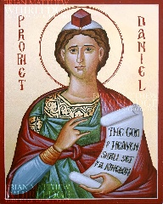
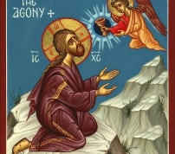
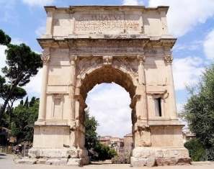
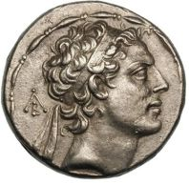
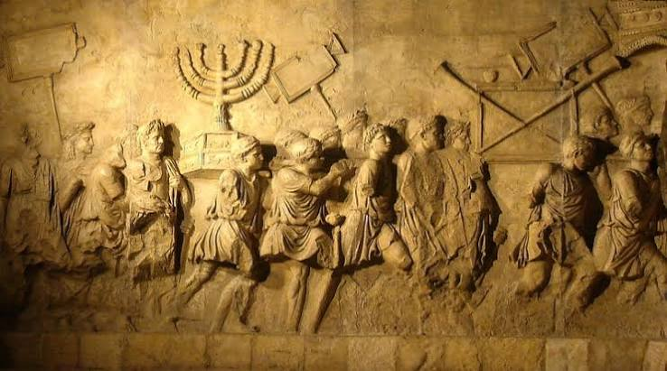
Roman Army in Mark 13:14
Daniel 7:13 in Mark 13:26
“His forces will come and make the sanctuary fortress impure. They will stop the daily sacrifice and set up a desolating monstrosity.” Dan 11:31
Antiochus IV Epiphanes 167 BCE

Mark 13:24-25 quotes Joel 2:30-31. Acts 2:16-21 doesn’t understand this as a literal darkening of heavenly bodies.

Many of the things listed in Mark 13 – famine, war, earthquakes, false leaders, division, trials, families turning against each other– could apply to any time of social stress – Joel’s, Daniel’s, Jesus’, the Jewish War, or our own.
“In those days, after the suffering of that time, the sun will become dark, and the moon won’t give its light. ²⁵ The stars will fall from the sky, and the planets and other heavenly bodies will be shaken. ²⁶ Then they will see the Human One coming in the clouds with great power and splendor. ²⁷ Then he will send the angels and gather together his chosen people from the four corners of the earth, from the end of the earth to the end of heaven.

²⁸ “Learn this parable from the fig tree. After its branch becomes tender and it sprouts new leaves, you know that summer is near. ²⁹ In the same way, when you see these things happening, you know that he’s near, at the door. ³⁰ I assure you that this generation won’t pass away until all these things happen. ³¹ Heaven and earth will pass away, but my words will certainly not pass away.

³² “But nobody knows when that day or hour will come, not the angels in heaven and not the Son. Only the Father knows. ³³ Watch out! Stay alert! You don’t know when the time is coming. ³⁴ It is as if someone took a trip, left the household behind, and put the servants in charge, giving each one a job to do, and told the doorkeeper to stay alert. ³⁵ Therefore, stay alert! You don’t know when the head of the household will come, whether in the evening or at midnight, or when the rooster crows in the early morning or at daybreak. ³⁶ Don’t let him show up when you weren’t expecting and find you sleeping. ³⁷ What I say to you, I say to all: Stay alert!”

Mark 13:24-37
First Sunday of Advent: Stay Awake! Keep hope alive! Don’t let the pressures of the world fracture the community of faith!

Following Mark 13: Plot to Kill Jesus, Anointing for Death, Last Supper, Peter’s Denial, Prayer in Gethsemane.
Mark is telling the story of Jesus’ arrest, suffering, and death amid the war and he’s saying don’t be like those first disciples. Don’t fall asleep. Stay alert! And don’t let this war tear apart our community!

Josephus, Jewish War 6. 243 …. “The Romans, now that the rebels had fled to the city, and the sanctuary itself and all around it were in flames, carried their standards into temple court and, setting them up opposite the eastern gate, there sacrificed to them, and with rousing acclamations hailed Titus as imperator.

Jewish War
66-70 CE
Mark probably written during or soon after.

Arch of Titus – Symbol of Roman victory

Mark 13:2-3
Jesus responded, “Do you see these enormous buildings? Not even one stone will be left upon another. All will be demolished. Jesus was sitting on the Mount of Olives across from the temple. Peter, James, John, and Andrew asked him privately, ⁴ “Tell us, when will these things happen? What sign will show that all these things are about to come to an end?”

